**Swedish Method:**

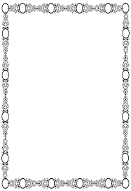Do you know the context and setting of this passage?

What questions do you have about the text?

What feelings are in or evoked by the text?

What stands out for you in this passage or is key for understanding?

What have you learned from this passage that you could share?

Biblical Theology

Staying on

the Line

**Transformational**

**Intent**

Melodic Line Main Idea

Genre

Structure

Travelling instructions

Text over Framework

Ask good questions